LAPORANPENGERJAANUJIKOMPETENSIKEJURUANSMK MAHARDHIKA BATUJAJAR

TAHUNPELAJARAN2022-2023

KOMPETENSIKEAHLIAN : RekayasaPerangkatLunakKELAS : XII RPL 1

NAMALENGKAP : Isa Nazarina

NIS :

PAKETSOAL :

JENISAPLIKASI :Web

ALOKASIWAKTU :24jam

# PENJADWALANKEGIATAN

|  |  |  |  |  |  |  |  |  |  |  |  |  |  |  |  |  |  |  |  |  |  |  |  |  |  |  |
| --- | --- | --- | --- | --- | --- | --- | --- | --- | --- | --- | --- | --- | --- | --- | --- | --- | --- | --- | --- | --- | --- | --- | --- | --- | --- | --- |
| No. | Kegiatan | Alokasi Waktu | | | | | | | | | | | | | | | | | | | | | | | | Keterangan |
| 1 | 2 | 3 | 4 | 5 | 6 | 7 | 8 | 9 | 10 | 11 | 12 | 13 | 14 | 15 | 16 | 17 | 18 | 19 | 20 | 21 | 22 | 23 | 24 |
| 1. | Analisis Soal |  |  |  |  |  |  |  |  |  |  |  |  |  |  |  |  |  |  |  |  |  |  |  |  |  |
| 2. | Persiapan Perangkat |  |  |  |  |  |  |  |  |  |  |  |  |  |  |  |  |  |  |  |  |  |  |  |  |  |
| 3. | Persiapan Software |  |  |  |  |  |  |  |  |  |  |  |  |  |  |  |  |  |  |  |  |  |  |  |  |  |
| 4. | Perancangan Algoritma |  |  |  |  |  |  |  |  |  |  |  |  |  |  |  |  |  |  |  |  |  |  |  |  |  |
| 5. | Desain Database |  |  |  |  |  |  |  |  |  |  |  |  |  |  |  |  |  |  |  |  |  |  |  |  |  |
| 6. | Implementasi Database/Buat Ke MySQL |  |  |  |  |  |  |  |  |  |  |  |  |  |  |  |  |  |  |  |  |  |  |  |  |  |
| 7. | Desain User Interface |  |  |  |  |  |  |  |  |  |  |  |  |  |  |  |  |  |  |  |  |  |  |  |  |  |
| 8. | Implementasi Kode Program |  |  |  |  |  |  |  |  |  |  |  |  |  |  |  |  |  |  |  |  |  |  |  |  |  |
| 9. | Uji Coba Aplikasi |  |  |  |  |  |  |  |  |  |  |  |  |  |  |  |  |  |  |  |  |  |  |  |  |  |
| 10. | Uji Cetak Struk |  |  |  |  |  |  |  |  |  |  |  |  |  |  |  |  |  |  |  |  |  |  |  |  |  |
| 11. | Uji Coba Buat Laporan |  |  |  |  |  |  |  |  |  |  |  |  |  |  |  |  |  |  |  |  |  |  |  |  |  |
| 12. | Upload Ke Hosting |  |  |  |  |  |  |  |  |  |  |  |  |  |  |  |  |  |  |  |  |  |  |  |  |  |
| 13. | Dokumentasi |  |  |  |  |  |  |  |  |  |  |  |  |  |  |  |  |  |  |  |  |  |  |  |  |  |

# PERSIAPANPERANGKATKERAS

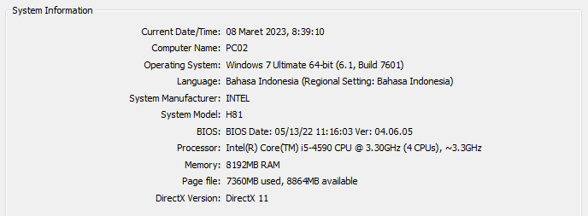

# PERSIAPANPERANGKATLUNAK

* Astah
* Balsamiq
* XAMPP Control Panel
* Visual Code Studio
* Chrome

# PERANCANGANALGORITMAAPLIKASI

# Activity diagram

# Activity diagram login

# C:\Users\USER\AppData\Local\Microsoft\Windows\INetCache\Content.Word\Login pengaduan.jpg

# Activity Diagram Register

# 

# Activity diagram Membuat PengaduanD:\tugas pbo\Activity Diagram0.jpg

# Activity Diagram Menanggapi/Admin/Petugas

# D:\tugas pbo\Activity Diagram menangapi pengaduan0.jpg

# Tambah data User/admin

# D:\tugas pbo\Activity Diagram menangapi pengaduan12.jpg

# Edit data user User/admin

# D:\tugas pbo\Edit data.jpg

# Activity diagram Hapus tanggapan

# D:\tugas pbo\hapus tangapan.jpg

# Hapus data user

# D:\tugas pbo\Hapus data user.jpg

# PERANCANGANDESAINBASISDATA

# Class diagram

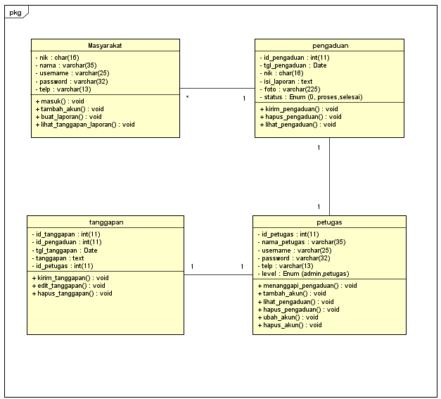

# ERD

# C:\Users\labkom1\Downloads\WhatsApp Image 2023-03-10 at 1.58.01 PM.jpeg

# DUMMYDATA

# Masyarakat

|  |  |  |  |  |
| --- | --- | --- | --- | --- |
| **NIK** | **Nama** | **Username** | **Password** | **Telepon** |
| 6969 | Tomoe Hiyori | burungduolingo | sunshine | 089654362 |
| 6678544564 | Reina | reichan | 123 | 08653435352 |
| 0867544455 | Siti Kusmini | tikus123 | sikus | 08245545965 |
| 9887466668 | Nanang Ismail | nangis | nais | 08769612345 |
| 9785333556 | Mika Kagehira | mikakghr | valkyrie2 | 087654523421 |

* **Petugas**

|  |  |  |  |  |  |
| --- | --- | --- | --- | --- | --- |
| * **ID Petugas** | **Nama Petugas** | **Username** | **Password** | **Telepon** | **Level** |
| 69 | Nazy | Nana7 | 6969 | 08886746524 | Petugas |
| 6969 | Tigusa | tigusavoice | ochigu | 08673459749 | Admin |
| 6764453347 | Shiraito Akira | Ashira | shiraito | 08436554355 | Petugas |
| 6838123579 | Shiraito Kira | Kishira | yami | 08974368923 | Admin |
| 6456323545 | Jun Sazanami | furi123 | sazanamix | 086324672813 | Petugas |

* **Pengaduan**

|  |  |  |  |  |  |
| --- | --- | --- | --- | --- | --- |
| **ID Pengaduan** | **Tanggal Pengaduan** | **NIK** | **Isi Laporan** | **Foto** | **Status** |
| 01 | 2023-01-08 | 6678544564 | bang ini gimana | galon susu.jpg | Proses |
| 02 | 2023-02-28 | 6678544564 | bang | noImage.jpg | Selesai |
| 03 | 2023-04-09 | 9785333556 | bansos plis | valkyrie.jpg | Proses |
| 04 | 2023-08-12 | 6969 | vaksin | rs.jpg | Proses |
| 05 | 2023-09-18 | 6969 | Kelebihan uang | skinker.jpg | selesai |

# PEMBUATANBASISDATA(MySQLCode)

* **Database Masyarakat**

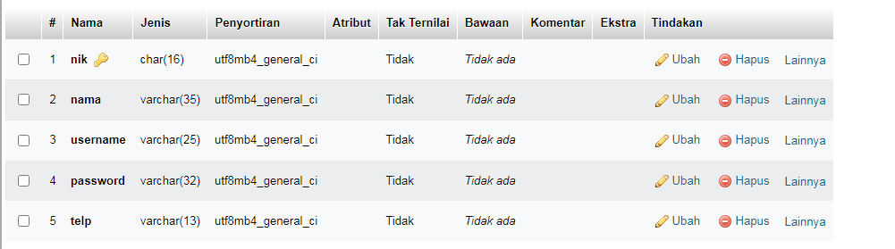

* **Database Petugas**

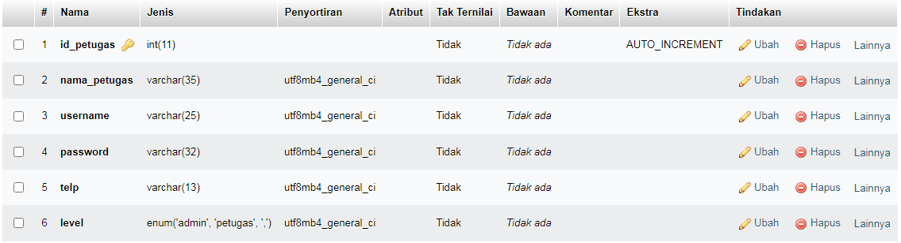

* **Database Pengaduan**

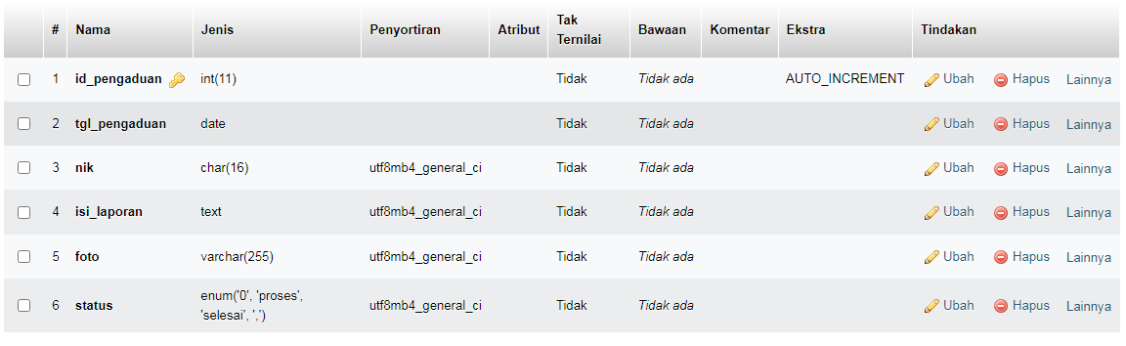

* **Database Tanggapan**

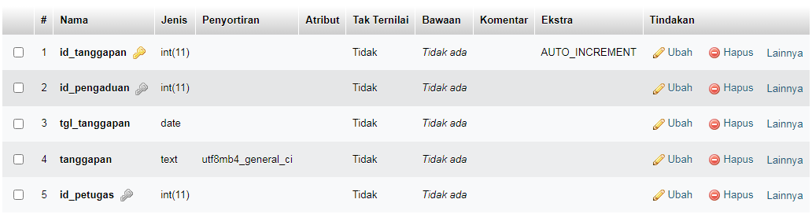

# PERANCANGANTAMPILANANTARMUKA(UI)WEB

* + **Aplikasi pengaduan masyarakat**

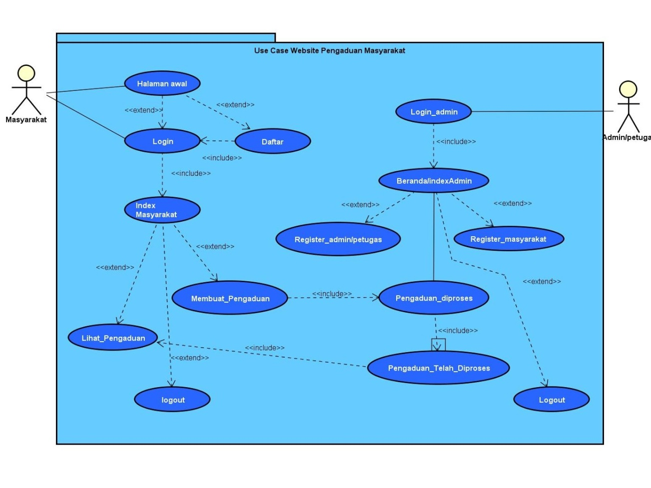

1. Admin dashboard

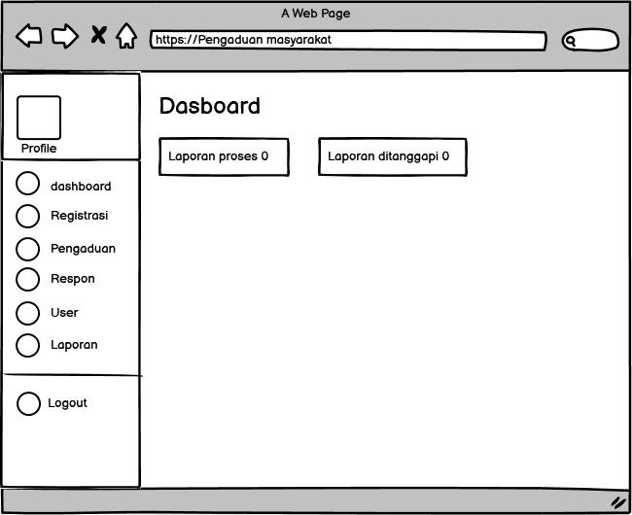

* From Tamabah akun Masyarakat di admin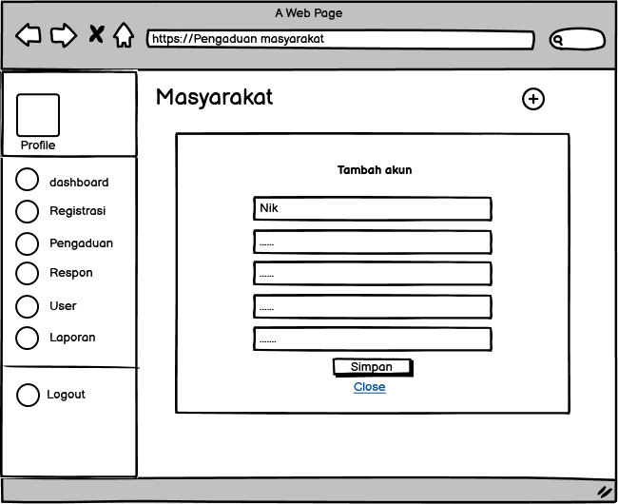
* From Register Admin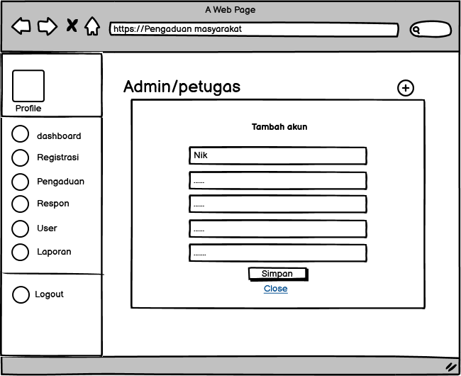

1. Tampilan Petugas

* Dash board Petugas

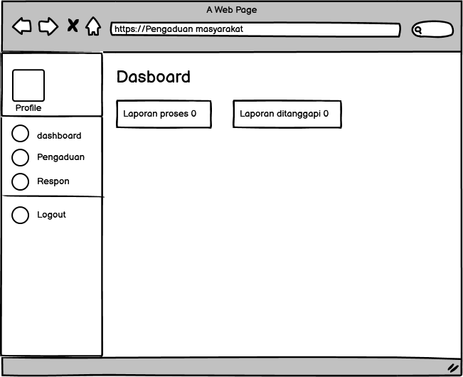

* From Menanggapi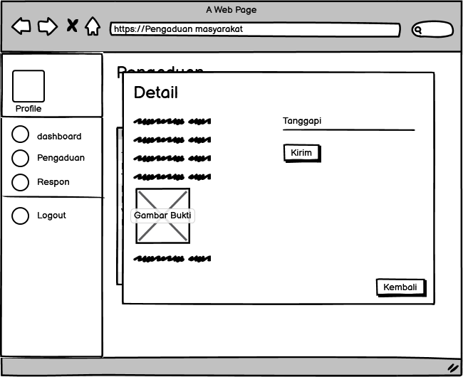

1. Tampilan Masyarakat

* Dashboard Masyarkat

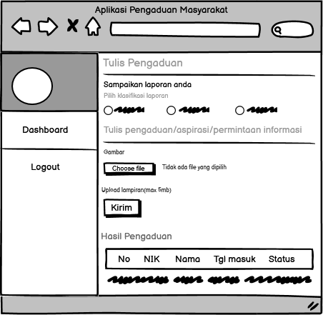

# PEMBUATANSTRUKTURWEB(HTML)

<!DOCTYPE html>

<html>

<head>

<title>Registration Page</title>

</head>

<body bgcolor="gray">

<br>

<br>

<form method="POST" action="aksi-register.php">

<label>NIK</label><br>

<input type="text" id="nik" name="nik" size="20" required/><br><br>

<label>Nama</label><br>

<input type="text" id="nama" name="nama" size="20" required/><br><br>

<label>

Username<br>

<input type="username" id="username" name="username" required/><br><br>

Password<br>

<input type="password" id="password" name="password" required><br><br>

<label>

No. Telepon<br>

</label>

<input type="text" name="telp" size="20"/><br><br>

<input type="submit" value="submit" name="submit">

</form>

</body>

</html>

1. PEMBUATAN STYLEWEB (CSS)

body{

font-family: Helvetica;

background-color: lightslategray;

}

.container{

padding: 50px;

background-color: lightslategray;

}

.center {

text-align: center;

border: 3px solid white;

}

input[type=text], input[type=password], textarea{

width: 100%;

padding: 15px;

margin: 5px 0 22px 0;

display: inline-block;

border: none;

background-image: "img/bg-gray.png";

}

input[type=text]:focus, input[type=password]:focus {

background-color: white;

outline: none;

}

div{

padding: 10px 0;

}

hr{

border: 1px solid white;

margin-bottom: 25px;

}

.registerbtn{

background-color: pink;

color: red;

padding: 16px 20px;

margin: 8px 0;

border: none;

cursor: pointer;

width: 100%;

opacity: 0.9;

}

.registerbtnhover{

opacity: 1;

1. PEMBUATANKODEWEB(PHP/JS)

* Index.php

<!DOCTYPE html>

<html>

<head>

<title>Aplikasi Pengaduan Masyarakat</title>

<link rel="shortcut icon" href="https://cepatpilih.com/image/logo.png">

<meta charset="utf-8">

<meta http-equiv="X-UA-Compatible" content="IE=edge,chrome=1">

<meta name="viewport" content="width=device-width, initial-scale=1.0, maximum-scale=1.0, user-scalable=0">

<link href="//cdnjs.cloudflare.com/ajax/libs/materialize/0.98.2/css/materialize.min.css" rel="stylesheet" id="bootstrap-css">

<script src="//cdnjs.cloudflare.com/ajax/libs/materialize/0.98.2/js/materialize.min.js"></script>

<script src="//code.jquery.com/jquery-1.11.1.min.js"></script>

<link rel="stylesheet" type="text/css" href="css/style.css">

<!-- ICONS -->

<link rel="apple-touch-icon" sizes="76x76" href="assets/img/apple-icon.png">

<link rel="icon" type="image/png" sizes="96x96" href="assets/img/favicon.png">

</head>

<body style="background: url(img/bg-gray.jpg); background-size: cover;">

<div class="container">

<?php

include 'conn/koneksi.php';

if(@$_GET['p']==""){

include_once 'login.php';

}

elseif(@$_GET['p']=="login"){

include_once 'login.php';

}

elseif(@$_GET['p']=="logout"){

include_once 'logout.php';

}

?>

</div>

</body>

</html>

* Koneksi.php

<?php $koneksi=mysqli_connect("localhost","root","","pdm"); ?>

* From-pengaduan/ tambah data

<?php

if(isset($_POST['kirim'])){

$nik = $_SESSION['data']['nik'];

$tgl = date('Y-m-d');

$foto = $_FILES['foto']['name'];

$source = $_FILES['foto']['tmp_name'];

$folder = './../img/';

$listeks = array('jpg','png','jpeg');

$pecah = explode('.', $foto);

$eks = $pecah['1'];

$size = $_FILES['foto']['size'];

$nama = date('dmYis').$foto;

if($foto !=""){

if(in_array($eks, $listeks)){

if($size<=100000){

move_uploaded_file($source, $folder.$nama);

$query = mysqli_query($koneksi,"INSERT INTO pengaduan VALUES (NULL,'$tgl','$nik','".$_POST['laporan']."','$nama','proses')");

if($query){

echo "<script>alert('Pengaduan Akan Segera di Proses')</script>";

echo "<script>location='index.php';</script>";

}

}

else{

echo "<script>alert('Ukuran Gambar Tidak Lebih Dari 5MB')</script>";

}

}

else{

echo "<script>alert('Format File Tidak Di Dukung')</script>";

}

}

else{

$query = mysqli_query($koneksi,"INSERT INTO pengaduan VALUES (NULL,'$tgl','$nik','".$_POST['laporan']."','noImage.png','proses')");

if($query){

echo "<script>alert('Pengaduan Akan Segera Ditanggapi')</script>";

echo "<script>location='index.php';</script>";

}

}

}

?>

* Dashboard/menampilkan tabel Pengaduan

<td><h4 class="grey-text hide-on-med-and-down">Hasil pengaduan</h4></td>

</tr>

<td>

<table border="3" class="responsive-table striped highlight">

<tr>

<td>No</td>

<td>NIK</td>

<td>Nama</td>

<td>Tanggal Masuk</td>

<td>Status</td>

<td>Opsi</td>

</tr>

<?php

$no=1;

$pengaduan = mysqli_query($koneksi,"SELECT * FROM pengaduan INNER JOIN masyarakat ON pengaduan.nik=masyarakat.nik INNER JOIN tanggapan ON pengaduan.id_pengaduan=tanggapan.id_pengaduan WHERE pengaduan.nik='".$_SESSION['data']['nik']."' ORDER BY pengaduan.id_pengaduan DESC");

while ($r=mysqli_fetch_assoc($pengaduan)) { ?>

<tr>

<td><?php echo $no++; ?></td>

<td><?php echo $r['nik']; ?></td>

<td><?php echo $r['nama']; ?></td>

<td><?php echo $r['tgl_pengaduan']; ?></td>

<td><?php echo $r['status']; ?></td>

<td>

<!-- ditanggapi -->

<div id="tanggapan&id_pengaduan=<?php echo $r['id_pengaduan'] ?>" class="modal">

<div class="modal-content">

<h4 class="white-text">Detail</h4>

<div class="col s12">

<p>NIK : <?php echo $r['nik']; ?></p>

<p>Dari : <?php echo $r['nama']; ?></p>

<p>Petugas : <?php echo $r['nama_petugas']; ?></p>

<p>Tanggal Masuk : <?php echo $r['tgl_pengaduan']; ?></p>

<p>Tanggal Ditanggapi : <?php echo $r['tgl_tanggapan']; ?></p>

<?php

if($r['foto']=="kosong"){ ?>

<img src="../img/mafu.png" width="100">

<?php }else{ ?>

<img width="100" src="../img/<?php echo $r['foto']; ?>">

<?php }

?>

<br><b>Pesan</b>

<p><?php echo $r['isi_laporan']; ?></p>

<br><b>Respon</b>

<p><?php echo $r['tanggapan']; ?></p>

<!-- ditanggapi -->

</tr>

<?php }

?>

* Delete.php

<?php

if(@$_GET['p']==""){

include_once 'dashboard.php';

}

elseif(@$_GET['p']=="dashboard"){

include_once 'dashboard.php';

}

elseif(@$_GET['p']=="pengaduan_hapus"){

$query=mysqli_query($koneksi,"SELECT * FROM pengaduan WHERE id_pengaduan='".$_GET['id_pengaduan']."'");

$data=mysqli_fetch_assoc($query);

unlink('../img/'.$data['foto']);

if($data['status']=="proses"){

$delete=mysqli_query($koneksi,"DELETE FROM pengaduan WHERE id_pengaduan='".$_GET['id_pengaduan']."'");

header('location:index.php?p=dashboard');

}

elseif($data['status']=="selesai"){

$delete=mysqli_query($koneksi,"DELETE FROM pengaduan WHERE id_pengaduan='".$_GET['id_pengaduan']."'");

if($delete){

$delete2=mysqli_query($koneksi,"DELETE FROM tanggapan WHERE id_pengaduan='".$_GET['id_pengaduan']."'");

header('location:index.php?p=dashboard');

}

}

}

elseif(@$_GET['p']=="more"){

include_once 'more.php';

}

?>

</div>

</div>

1. UJICOBA

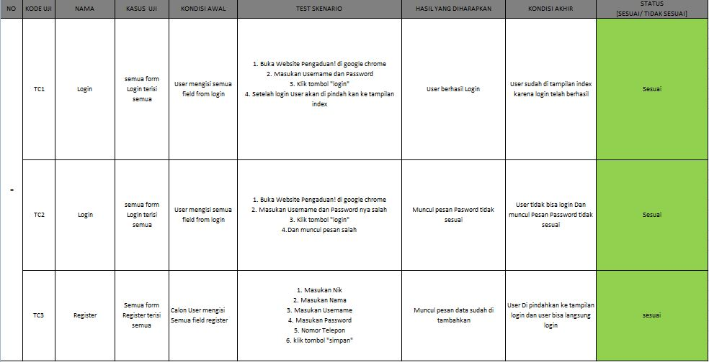

1. REVISI
2. PENENTUANDOMAINDANHOSTING
3. UPLOADWEBKE HOSTING
4. UPLOADWEBKEGITHUB
5. PEMBUATANUSERGUIDANCE